**The 2015-2016 Drought in South Africa**

National Outcome Forecast Analysis

Analysis of Fourteen Livelihood Zones in Limpopo, KwaZulu-Natal and Free State Provinces, with a Synthesis for the Remainder of the Country



Financed by:

The South Africa Vulnerability Assessment Committee (SAVAC) is comprised of:

* Department of Social Development;
* Office of the President,;
* Department of Health;
* Statistics South Africa
* University of Pretoria;
* University of KwaZulu Natal;
* Provincial Depratment of Agriculture;
* OXFAM;
* FAO,
* UN Partners (UNDP, UNICEF, UNFPA, UNAIDS, FAO)
* Botswana Council of Non-Governmental Organisations (BOCONGO)

The SAVAC is led by the Department of Agriculture, Forestry and Fisheries with technical support from the SADC Regional Vulnerability Assessment and Technical Assistance Team

|  |  |  |
| --- | --- | --- |
| **Enquiries: please contact SAVAC Secretariat**  Department of Agriculture, Forestry and Fisheries | Postal and courier address:  XA-GF-02, Private Bag X250 Pretoria, 001  South Africa  Physical address:  20 Agriculture Place, Steve Biko Street, Arcadia, 0083 | Tel. +27 (0)123196736  Fax. +27 (0)123196694  Email: [MolateloMAM@daff.gov.za](mailto:MolateloMAM@daff.gov.za) |

##### 

Figure 1: National Livelihood Zone Map of South Africa

### 

### Acknowledgements

The South Africa Vulnerability Assessment Committee (SAVAC) and the participating consultant would sincerely like to extend their gratitude to the Republic of South Africa Government, through the Department of Agriculture, Forestry and Fisheries for providing coordination and oversight in additional to material support of transport, financial resources, office equipment and stationary and for this exercise.

The SAVAC would also want to extend its gratitude to all agencies and government departments, who willingly met with the author and discussed the information at their disposal. In particular, the SAVAC

Thanks are also due to provincial governments, who provided data and participated in all programmes leading up to this exercise, such as the baselines assessments.

The SAVAC also thanks the SADC Regional Vulnerability Assessment and Analysis (RVAA) programme through the Programme Management Unit (PMU) for making the whole process a success through the provision of trainers, team leaders, stationery and financial resources.

### Introduction

The Department of Agriculture, Forestry and Fisheries (DAFF) in collaboration with the Southern African Development Community (SADC) Regional Vulnerability Assessment and Analysis (RVAA) Programme is working towards strengthening food insecurity and vulnerability assessment in South Africa. Through this partnership, a number of activities have been conducted towards institutionalisation of the South African Vulnerability Assessment Committee (SAVAC). The most recent activities include:

* Baselines assessments in Limpopo province;
* An Outcome Forecast assessment in Limpopo, and;
* Baselines assessments in Free State and KwaZulu-Natal provinces.

The size and complexity of South Africa as a country requires the vulnerability assessment system to be decentralised to provincial level or through the establishment of Provincial Vulnerability Assessment Committees (PVACs). The first provincial vulnerability assessment committee (PVAC) formed was the Limpopo VAC (LimVAC) and further PVACs have been formed in KwaZulu-Natal and Free State. As result of these efforts, full baselines with livelihoods and food security indicators’ assessments have been carried out in *fourteen livelihood zones* by 29 April 2016.

The SAVAC uses a system that combines the Household Economy Approach (HEA), which provides a longitudinal or temporal picture of the *depth* of changing household food access and living standards, with the Food Security Continuum (the ‘Continuum’), which provides a detailed cross-sectional ‘snapshot’ description of people and household under different food security indicators. The basic principle underlying the Household Economy Approach is that the understanding of local livelihoods is essential for analysing the impact (at household level), of shocks such as drought, conflict or market changes. The Household economy analysis establishes a picture of typical, normal livelihood patterns for households in different geographical areas, in order to understand a range of conditions that local communities must cope with in a normal year as its baseline assessment.

Obviously, it is not practical to analyse in detail the various components of each and every household’s livelihood in the country, so a level of aggregation needs to be applied.

The baseline assessment also focuses on understanding the various household sources of food, income and expenditure patterns among the four wealth groups (‘Very Poor’, ‘Poor’, ‘Middle’ and ‘Better Off’) defined by community key informants. It also explores issues related to household vulnerability as well as the coping strategies and options they undertake during bad years.

The baseline information is then used as a reference point for modelling the likely effects of shocks such as drought, floods and market failure. These shocks may affect people’s ability to maintain their livelihoods or in extreme cases, they could be life-threatening. Any external response to these shocks needs to be based on the provision information and analysis, which gives solid guidance for short, medium and long term relief, recovery and development initiatives.

The purpose of the forecast scenario analysis exercise was to establish whether livelihoods of the household in the area covered by the zones have been affected, compared with the baseline outcomes. This will be used to demonstrate the approach and provide recommendations for appropriate policy action.

A team of twenty eight personnel, trained in vulnerability assessment and analysis methodologies, was engaged in defining problem specifications and modelling the possible effects on households. Crop failure may, for example, leave one group of households without anything to eat if crop production is their main source of food but another group may be able to cope because they have alternative sources of food and income that can make up for lost crop production.

Baseline data was used to determine the key parameters that needed to be analysed and these included crop and livestock production, prices, and government assistance programmes among others. The SAVAC also consulted Department of Agriculture Officers in the municipalities within the livelihood zones and villages to seek their technical input and participation in the forecast analysis data collection.

This report focuses on the current agricultural season in terms of general rainfall and weather conditions, crop and Livestock production and household sources of food and cash income.

The analysis combines current year monitoring data with baseline data to project the most likely scenario in the quarter of the 2015/16 consumption year.

### A Summary of the Assessment Process

The process of baseline livelihood profiling started in 2014 with a livelihood zoning exercise, given the significance of geography as a determinant of livelihood patterns. A livelihood zone was visited and the next step was to define the wealth groups in the livelihood zone as wealth determines options available to the household for access to food and income.

Having patterned households according to where they live and their wealth[1], the next step was to generate baseline livelihood profiles for typical households in each wealth group for a defined baseline or reference consumption year. An understanding of food access is gained by investigating the sum of ways households obtain food; that is, how much food they get from their own direct food crop production, their livestock, gifts from others, exchanges or barters and from purchases. To understand the latter, information is also collected on how much cash income is earned in a year and what essential needs are met with the earned income.

Once the baseline is established, analysis can be made on the likely impact of a shock or hazard in the current year. This involves assessing how food access will be affected by the shock, what other food sources can be added or expanded to make up for the initial shortfall, given households’ asset holdings and capacity to earn more. After all these factors are considered, final deficits emerge once households have exhausting all their coping strategies. The SAVAC used the period April 2013 to March 2014 as the baseline or reference consumption year and therefore the current analysis reflects the impact of current problems for the forecast period of 2013 to 2014.

### The key parameters evaluated in April 2016

Using the baseline profiles, key parameters of change in each livelihood were identified. Each parameters affects a particular source of food, source of income or expenditure by changing either the amount of that source or its price. Examples of key parameters are the crops grown by households, their livestock, their labour, the social grants they receive from government and the food and non-food items that they purchase. With consumption, foodstuffs are grouped into staple and non-staple, and are combined with non-food expenditure to be compared with accepted standards, such as the Food Poverty Line (FPL), the Lower Bound and Upper Bound Poverty Lines (LBPL and UBPL).

Key parameters *always* compare the consumption year under review (in this case the period from April 2016 to March 2017) with the baseline consumption years (in all livelihoods it is the period from April 2013 to March 2014). An important characteristic of key parameters is whether they are *known* or *unknown*: known parameters are those which impact on livelihoods early in the consumption year and thus have already occurred, allowing their measurement, while unknown parameters have yet to occur during the consumption year and so cannot be measured. Of course, with the consumption year under review only just having started, there remain a lot of unknown parameters, which can only be included by constructing  *scenarios*.

The key parameters assessed included:

* Household own-production and how this year it compares with that in the baseline year March 2013;
* Household access to food from agricultural labour exchange and how this compares with the baseline year;
* Access to food from livestock products and how this compares with the baseline year;
* Quantities of income-activities in the current year from crop sales, livestock sales, agricultural labour, other casual labour, petty trading, access to social grants and other income activities that vary across wealth groups, compared with the baseline;
* The prices of maize and livestock in the current year compared with baseline year prices;
* The price of items in the minimum non staple basket (soap, paraffin, matches, sugar, Tea and salt), and the essential expenditure basket (education, medical, ploughing, seed, livestock treatment, cooking oil, clothing and grinding costs).

Comparison of key parameters data for 2013 with 2014 was done and the findings from this analysis formed the current year problem specification for scenario modelling.

### Methodology

The South Africa Vulnerability Assessment Committee (SAVAC), conducts assessments and analysis using a livelihoods based analytical framework, called the Household Economy Approach (HEA), for modelling its forecasts. There are four steps in a household or food economy analysis. The first two are concerned with dividing the population into groups of households that share similar characteristics in terms of their access to food and income. The assumption underlying these two steps is that access to food and income is determined by two factors; geography and economic status (i.e. relative wealth). While geography (where a household lives) determines the options for obtaining food and income, wealth generally determines a household’s ability to exploit those options. The third step involves developing a baseline picture of food access, income and expenditure for each wealth group. The fourth and final step is to combine information on baseline access with that on hazard and response in order to generate projections of future food and income access; the process can be summarised thus: Baseline + Hazard + Response = Outcome. The HEA methodology provides an opportunity for field officers to probe during discussions while at the same time observing the surrounding and non-verbal communication signs.

The HEA methodology has been widely adopted in most Member States in the SADC Region. The methodology saves on resources and time, making it affordable and sustainable under small budgets. The methodology also attempts to maximise the use of existing information and survey data. Besides data generated using HEA, SAVAC also uses a range of secondary sources of data such as the crop estimates from the Department of Agriculture, population projections from the Stats SA, inflation rates from Stats SA and price data from NAMC. The field exercise therefore provides an opportunity to verify secondary data with that obtained from the province, district and municipalities as well as the villagers.

The exercise was undertaken between 28th September 2015 and 17th October 2015, in which the team was divided into four groups and tasked to different parts of the zone. The villages visited were: Mankgodi, My darling, Ramakgapola, Ga-Sako, Glen-Roy, Monotwane, Ga-Monare, Ga-Mushi, Zamenkomste, Melbosch, Tshaulu, Tshixwadza, Malavuwe, Mudzidzidzi, Murunwa, Manotolwaneng, Matlakatle, Tsimanyane, Dikgalaopeng, Mohlaletsi, Manganeng, Ga Malekana, Ga Manyaka, Ga-Thaba, Kwaripe, Finale, Khujwana, Hoveni, Jamela, Ka-Homu, Nkomo, Hlaneki, Bode, Dzimauli, Tshiombo, Matangari and Mbahela.

In each village, the teams held meetings with key informants. The key informants consisted of community leadership such as Headmen, councillors, Municipal Agricultural Demonstrators, Livestock Officers, Community Development Officers and any other informant agreed upon by the Assessment team and the village leadership. The parameters discussed were as follows; rainfall situation, livestock and crop production, income sources and prices for food and selected non-food items.

The four groups reconvened in Tzaneen for data analysis and modelling of the study findings from 19th to 25th March 2015. The analysis started by completing the forms used to collect data in the field. Then the team separated into the five assessment groups to write and present the overall picture of the area they covered and problems faced as well as lessons learnt. The team thereafter reviewed concepts and were introduced to the analysis process.

The problem specification calculations were done manually using information collected from the field, baseline data and information from recent reports such as the Crop Estimate Survey report. The analysis was done by the team on the HEA spreadsheet using the baseline year data and current year forecasts.

The analysis used resilience level, lower bound and upper bound poverty lines to estimate individuals who are below the thresholds and require policy intervention.

The calculated problem specification percentages, which are the changes in the current year compared to baseline year, were entered into the analysis spreadsheet to calculate the food and expenditure deficit as well as number of people affected. The number of affected people was calculated using small area and enumeration area data for the respective areas for the 2008 Statistics South Africa Population and Household Census.

The results were then pooled together and a report was drafted.

### Findings / Results

#### Rainfall and Crop Production

The rainfall season started during the month of October 2009 in some parts of the entire zone, even though the rainfall amounts recorded did not give much moisture for ploughing and planting. Good rains for ploughing and planting activities in some areas started in mid-December 2014. The zones also experienced a dry spell towards the end of December 2014 up to the end of March 2015.

The crops which were planted during the month of November 2014 for the up- or dry-land farmers in the zone were highly affected by the dry spell and a poor yield was realized.

Production estimates for the April-July 2015 harvests shows that when compared with the baseline year, maize was the most affected crop, having been severely affected by the dry spells experienced from January to March and also affected by the heat wave. For major crops including maize, sorghum, beans and vegetables, this year is expected yield to be 5% - 30% of the baseline year. The official data largely confirms the findings of the team.

Figure 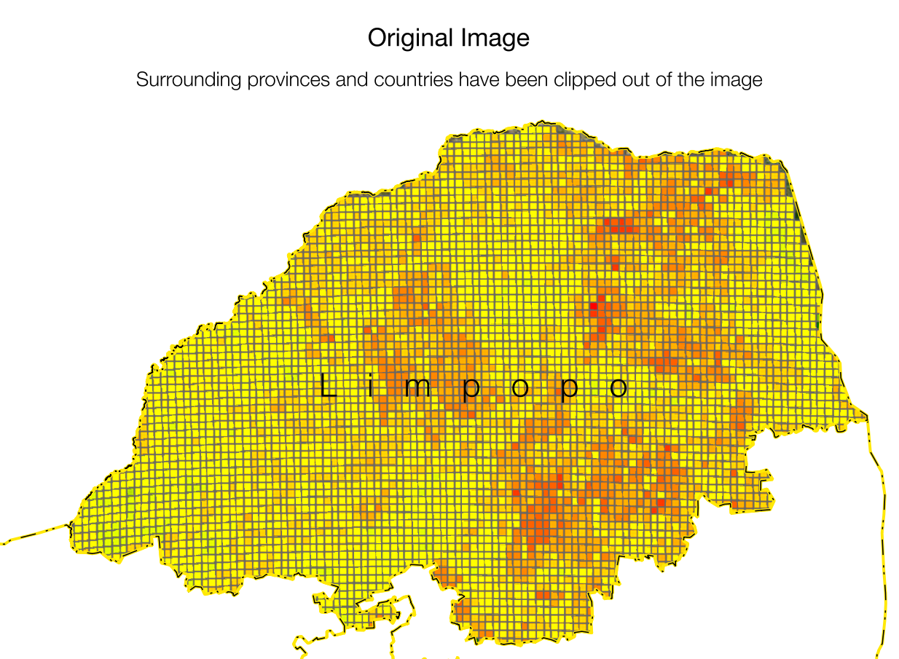2: Obtaining the drought-affected populations *–* Step 1

Figure 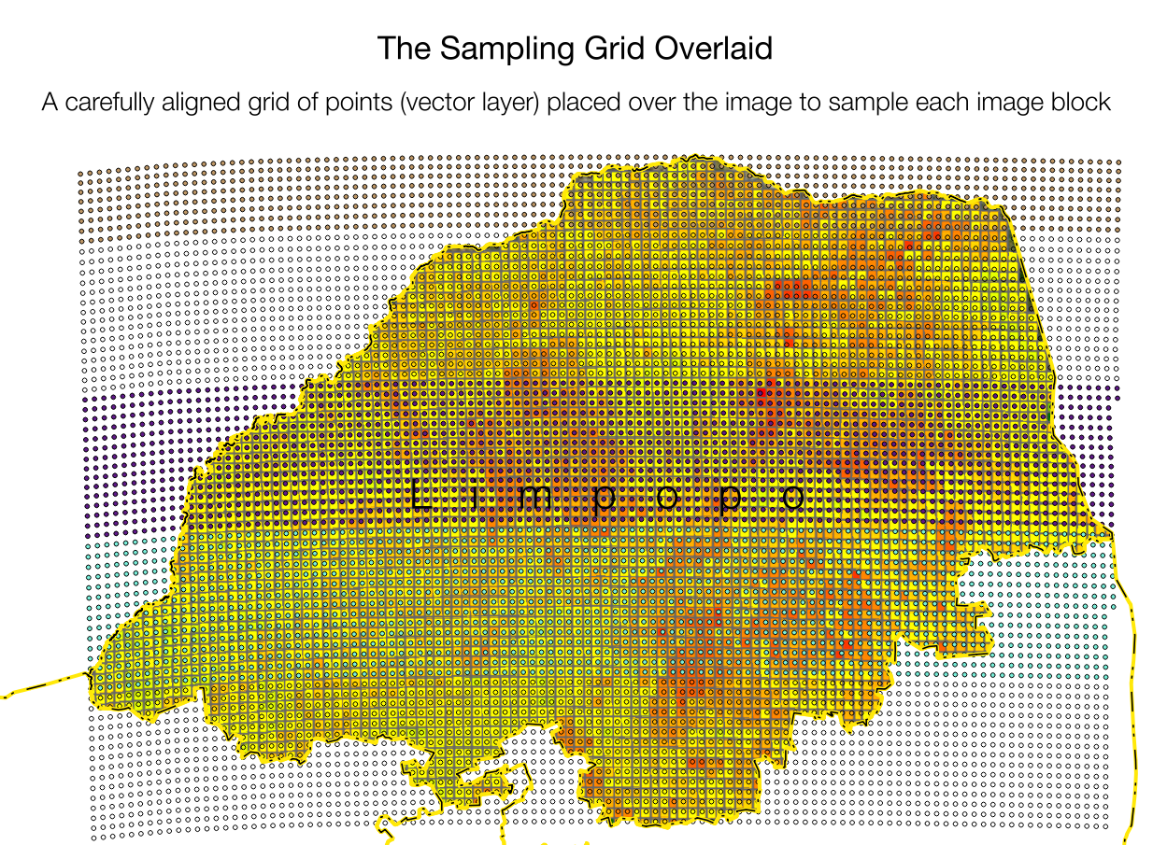3: Obtaining the drought-affected populations *–* Step 2

In general, the farmers anticipated lower yields (per hectare output) in the coming year (2015/16) when compared with the baseline year (2013/14).

**Analysis of affected areas**

The drought and its impact on cropping was not uniformly distributed across the province; it was not even uniformly distributed across livelihood zones. The team relied on images developed at the Limpopo Department of Agriculture that provide a spatial distribution on the performance of the growing season. **Figure 2** shows a particularly useful image, that of an index on the performance of the season, taking into account factors such as rainfall distribution, insolation, and other growing conditions.

Unfortunately, this image was difficult to translate into a vector format for deriving affected versus unaffected areas because of the grid overlaid onto it. The solution was to resampled it and this was done with an array or grid of vector points that was overlaid onto it. First of all, a grid of pints was constructed so that each point fell inside the pixel 'square' of the image. This is shown as Step 2 in **Figure 3**, where the points grid has been placed onto the original image. Since the image 'blocks' (between the grey lines) were not even in size, the points grid had to be adjusted to align to a 'best fit'.

A GIS 'plugin' tool (QGIS Desktop Application > Plugins > Point Sampling Tool, [www.qgis.org](http://www.qgis.org/)) was then used to extract the red, green and blue values from the original image. The result, Step 3, is shown in **Figure 4**.

Figure 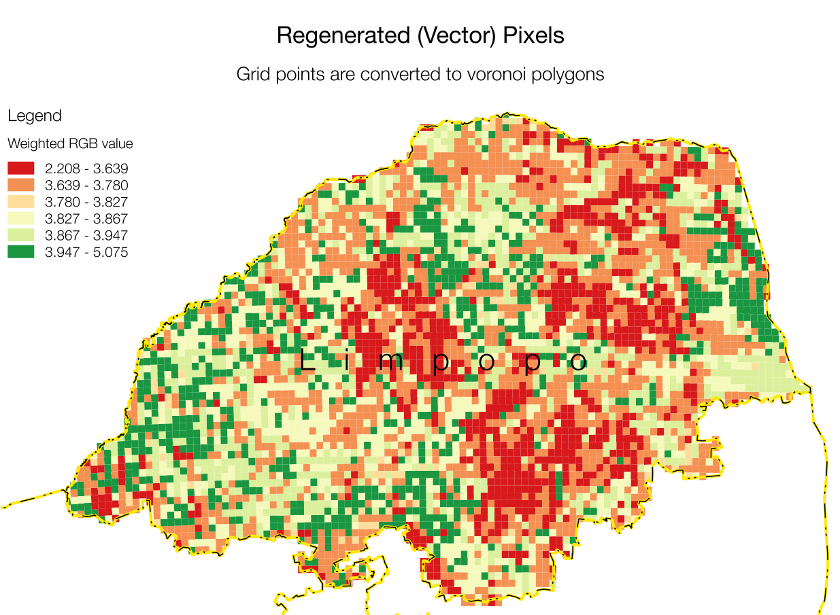5: Obtaining the drought-affected populations *–* Step 4

Figure 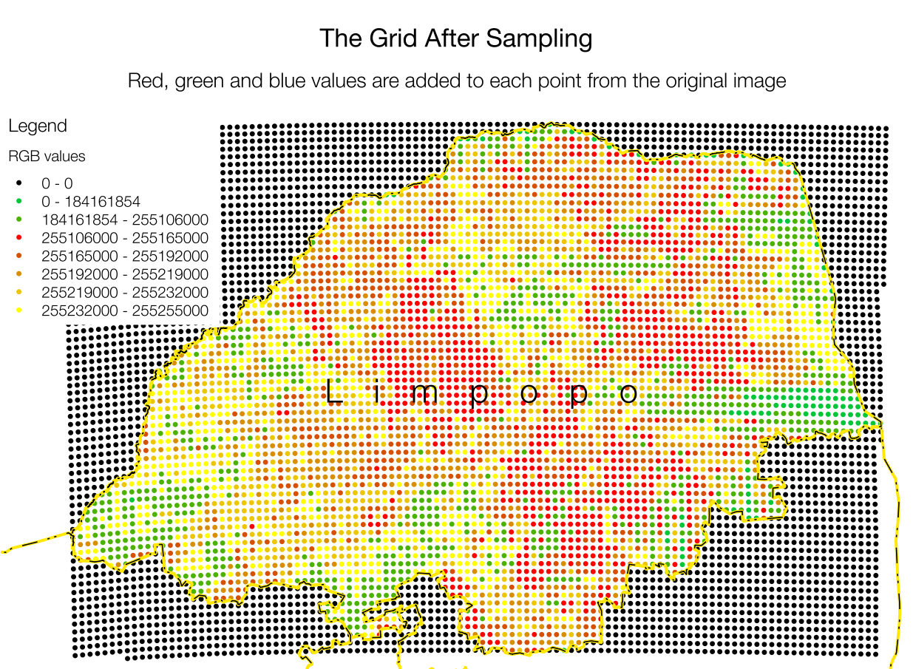4: Obtaining the drought-affected populations *–* Step 5

Figure 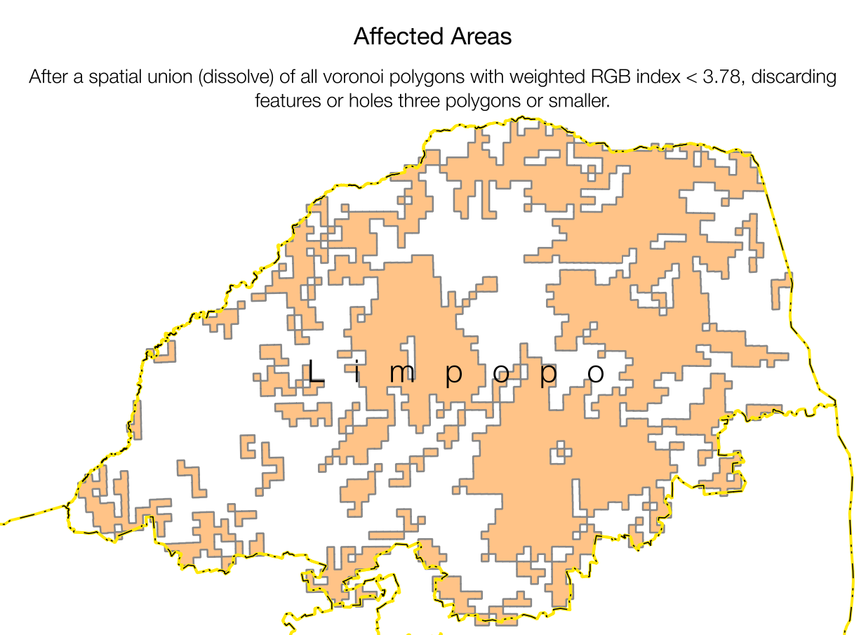6: Obtaining the drought-affected populations *–* Step 5

To reconstruct a pixel mosaic (without horizontal and vertical grid lines), the points are converted to Voronoi polygons, see **Figure 5**. These polygons are assigned a weighted RGB index (Red: 3, Green: 1, Blue: 5).

All features with the index below 3.78 are then combined in a spatial union (this is also called a 'dissolve' in some GISs), while any features – or holes – three blocks or smaller are discarded. This is Step 5.

The affected and unaffected populations for the four livelihood zones under study are calculated by overlaying the Small Area Layer from Statistics SAs Census data onto the affected areas in **Figure 6**. The SAVAC has attributed each Small Area to its livelihood zone, so the spatial query performs four drought groupings:

1. Small Areas that are *entirely within* the affected area are classified *affected* and are assigned a value of 1.

Figure 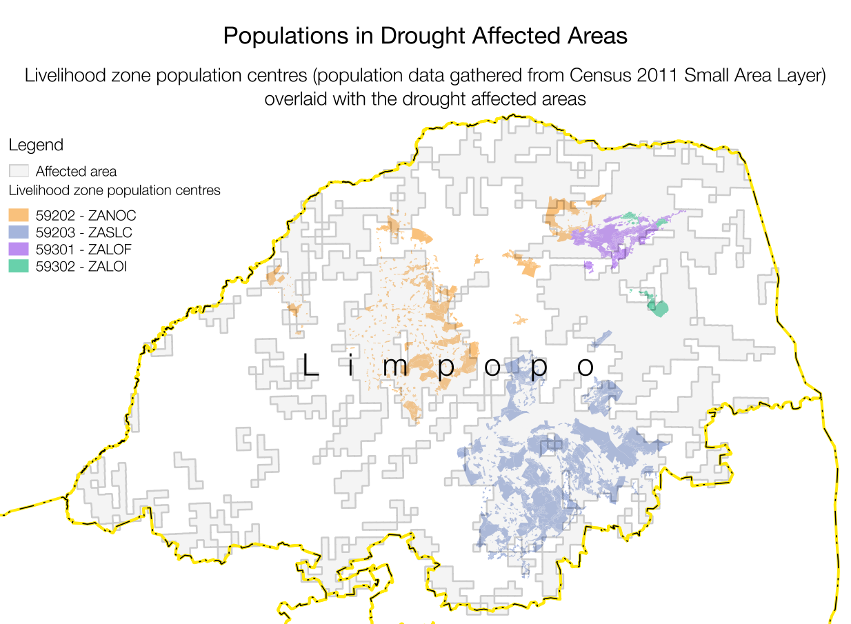7: Obtaining the drought-affected populations *–* Step 6

Figure 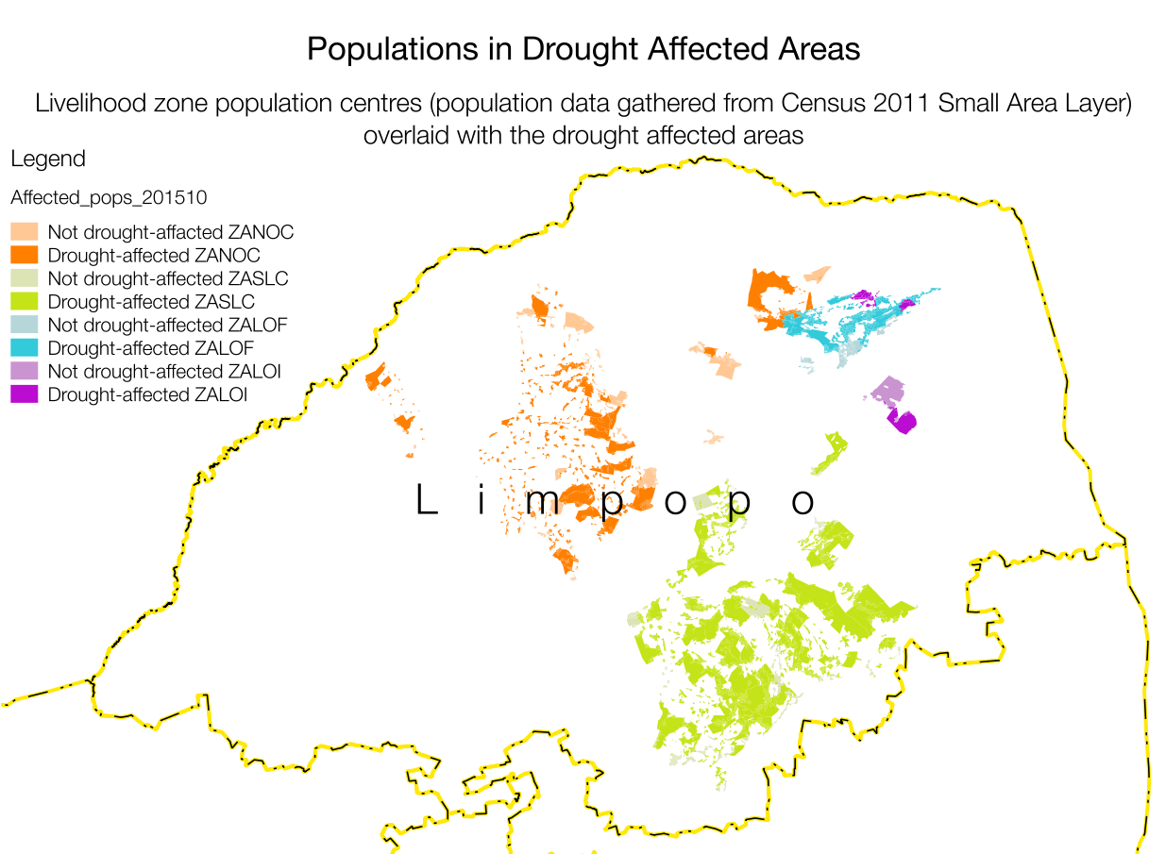8: Obtaining the drought-affected populations *–* Step 6

1. Small Areas that straddle an affected area boundary *and* *have* *more than 50%* of their area overlapping it are classified *affected* and assigned a value of 1.
2. Small Areas that straddle and affected area boundary *but have less than 50%* of their area overlapping it are classified *unaffected* and assigned a value of 0.
3. Small Areas that lie *entirely outside* the affected area are classified *unaffected* and are assigned a value of 0.

It is then a simple matter to sum the populations in the Small Areas by their constituent administrative areas (such as Municipality, District) and by livelihood zone. A pivot table is the simplest way to achieve this cross-tabulation. This is presented overleaf in **Table I**.

### It must be emphasised that ***drought is only one type of hazard****;* there are other kinds of hazards affecting people such as economic or prices changes. Hence, even people living in non-drought areas may still be at the same risk of food insecurity because of these other factors. Similarly, some people that exposed to a certain kind of hazard may not be vulnerable to it (for example, people earning a salary will likely not be as vulnerable to drought as people whop farm). This means that not all people listed in the above Table I are necessarily at risk. This will be explored in more detail in the next sections, by studying each livelihood system and exploring the impacts of the various changes in environmental and the economic situations for different wealth groups.

Table 1: Cross-tabulation of populations in livelihood zones and drought/non-drought affected areas against administrative areas

|  |  |  |  |  |  |  |  |  |  |
| --- | --- | --- | --- | --- | --- | --- | --- | --- | --- |
|  | **Population** | | | | | | | | |
| **District /** | 59202 - ZANOC | | 59203 - ZASLC | | 59301 - ZALOF | | 59302 - ZALOI | | Grand Total |
| **Municipalities** | No drought | Drought | No drought | Drought | No drought | Drought | No drought | Drought |
| Capricorn | 140,826 | 306,930 | 38,862 | 371,556 |  |  |  |  | 858,174 |
| Aganang | 6,480 | 123,258 |  |  |  |  |  |  | 129,738 |
| Blouberg | 49,269 | 84,663 |  |  |  |  |  |  | 133,932 |
| Lepele-Nkumpi |  |  | 26,274 | 163,392 |  |  |  |  | 189,666 |
| Molemole | 54,114 | 7,839 |  |  |  |  |  |  | 61,953 |
| Polokwane | 30,963 | 91,170 | 12,588 | 208,164 |  |  |  |  | 342,885 |
| Greater Sekhukhune |  |  | 152,022 | 646,206 |  |  |  |  | 798,228 |
| Elias Motsoaledi |  |  | 68,067 | 35,646 |  |  |  |  | 103,713 |
| Ephraim Mogale |  |  | 8,757 | 37,077 |  |  |  |  | 45,834 |
| Fetakgomo |  |  | 10,026 | 76,611 |  |  |  |  | 86,637 |
| Greater Tubatse |  |  | 50,154 | 242,718 |  |  |  |  | 292,872 |
| Makhuduthamaga |  |  | 15,018 | 254,154 |  |  |  |  | 269,172 |
| Mopani |  |  | 57,594 | 242,577 |  |  | 10,608 | 11,778 | 322,557 |
| Greater Giyani |  |  |  |  |  |  | 10,608 | 11,778 | 22,386 |
| Greater Letaba |  |  | 12,774 | 27,102 |  |  |  |  | 39,876 |
| Greater Tzaneen |  |  | 44,790 | 133,797 |  |  |  |  | 178,587 |
| Maruleng |  |  | 30 | 81,678 |  |  |  |  | 81,708 |
| Vhembe | 72,687 | 61,041 |  |  | 73,803 | 317,136 |  | 28,500 | 553,167 |
| Makhado | 72,687 | 60,780 |  |  | 35,391 | 75,789 |  |  | 244,647 |
| Mutale |  |  |  |  |  | 6,261 |  | 1,407 | 7,668 |
| Thulamela |  | 261 |  |  | 38,412 | 235,086 |  | 27,093 | 300,852 |
| Waterberg | 41,733 | 194,454 |  |  |  |  |  |  | 236,187 |
| Bela-Bela | 2,778 |  |  |  |  |  |  |  | 2,778 |
| Lephalale | 16,137 | 33,906 |  |  |  |  |  |  | 50,043 |
| Mogalakwena | 22,818 | 160,548 |  |  |  |  |  |  | 183,366 |
| **Grand Total** | **255,246** | **562,425** | **248,478** | **1,260,339** | **73,803** | **317,136** | **10,608** | **40,278** | **2,768,313** |

### North Eastern Limpopo Open Access Farming (ZALOF)

Villages were visited in Makhado municipality namely: Vuvha and Murunwa, both of which fall under the North Eastern Limpopo Open Access Farming (ZALOF) livelihood zone. The municipality has two service centres, Zhanani and Tshitale. These service centres are characterised with having moderate rainfall and in the September/October (2013/14) planting season for the baselines year, there was adequate infiltration which led to a normal planting season in which maize, beans and vegetables were planted. However, in the last (2014/15) summer season there were not sufficient rains to start planting, except along the rivers where farmers had already started planting crops such as maize and vegetables.

The affected areas were assigned the following problem specifications for crop productions:

Table 2 ZALOF crop problem specifications for affected areas

| Crop | Problem Specification |
| --- | --- |
| Maize | 40% |
| Beans | 19% |
| Pumpkin | 65% |
| Water melon | 102% |
| Groundnuts | 0% |

Note: A problem specification of 40% implies 60% loss in production for the last year when compared with the baseline.

In the unaffected areas the problem specifications for these items was 100% (no change).

In addition to poor crop performance, milk and meat output dropped and the problem specification for these activities this year is 60%, while that for cattle and goat sales are normal (100%) but for chickens it is 15%.

### Southern Limpopo Open Access Cattle and Crops (ZASLC)

Generally the onset of rains last season was delayed and the distribution was poor. Most parts of the zone received medium to low rainfall in the current season. However, some planting rains were received in February but the greater part of the livelihood zone experienced dry spells leading to a 5% to 20% food decrease compared with the baseline. The erratic rainfall was worst in the municipalities of Fetakgomo, Greater Tubatse, Elias Motsoaledi, Ephraim Mogale and Makhudu Thamaga. Maize, sugar beans, cotton and vegetables were most affected by the dry spells.

The affected areas were assigned the following problem specifications for crop productions:

Table 3 ZASLC crop problem specifications for affected areas

| Crop | Problem Specification |
| --- | --- |
| Maize | 29% |
| Cowpeas | 7% |
| Beans | 19% |
| Pumpkin | 100% |
| Water melon | 88% |
| Sweet potato | 0% |
| Groundnuts | 0% |

Note: A problem specification of 29% implies 71% loss in production for the last year when compared with the baseline.

In the unaffected areas the problem specifications for these items was 100% (no change).

In addition to poor crop performance, milk and meat output dropped dues to poor grazing. The problem specification for these activities this year is 57%, while that for pig sales is 36%, cattle sales is 63%, goat sales is 50%, sheep sales is 58% and chicken sales is 51%.

### Northern Open Access Cattle and Dry Land Crops (ZANOC)

Maize, beans, groundnuts, sweet potatoes and vegetables are the major crops produced in this livelihood zone. Generally, the onset of rains last season was delayed and the distribution has been poor and most farmers depend on rain-fed farming. Most areas within Lephalale, Polokwane, Molemole, Aganang, Mogalakwena, Makhado and Mogalakwena were characterised as having had dry spells with minimal to very low rainfall. Maize and cowpeas were the crops that were badly affected by the dry spell.

Table 4 ZANOC crop problem specifications for affected areas

| Crop | Problem Specification |
| --- | --- |
| Maize | 50% |
| Sorghum | 89% |
| Cowpeas | 0% |
| Beans | 83% |
| Groundnuts | 75% |

Note: A problem specification of 89% implies 11% loss in production for the last year when compared with the baseline.

In the unaffected areas the problem specifications for these items was 100% (no change).

In addition to poor crop performance, milk and meat output dropped dues to poor grazing. The problem specification for these activities this year is 50%, while cattle, goat and sheep sales remained normal (100%).

**Lowveld Open Access Irrigated Cropping Livelihood Zone (ZALOI)**

Maize, beans, groundnuts, sweet potatoes and vegetables are the major crops produced. The onset of rains during 2014/15 season was not delayed, comparing with the 2013/14 season. Greater Giyani, Thulamela and Mutale municipalities received the first rainfall in December 2014 and this lasted up until January 2015 in all three service centres (i.e. Hlaneki, Guwela and Mhlava Willem). Mhlava Willem was the only service center that continued to receive rainfall up to March, making their on yield better than other the other service centres. Hlaneki and Guwela service centres received the soil preparation and planting rains but the dry spells resulted in failure for all their crops, except for sweet potatoes. Irrigated crops, for the few households that have access to irrigation (mostly middle and better off households), were also normal.

The affected areas were assigned the following problem specifications for crop productions:

Table 5 ZALOI crop problem specifications for affected areas

| Crop | Problem Specification |
| --- | --- |
| Maize | 37% |
| Irrigated maize | 100% |
| Cowpeas | 33% |
| Beans | 75% |
| Rape (*morogo)* | 5% |
| Water melon | 13% |
| Sweet potato | 100% |
| Groundnuts | 5% |

Note: A problem specification of 37% implies 63% loss in production for the last year when compared with the baseline.

In the unaffected areas the problem specifications for these items was 100% (no change).

In addition to poor crop performance, milk and meat output dropped dues to poor grazing. The problem specification for these activities this year is 57%, while that for pig sales is 36%, cattle sales is 63%, goat sales is 50%, sheep sales is 58% and chicken sales is 51%.

#### Livestock prices

Cattle numbers have decreased by about 5% -10% from the baseline and this is attributed to the dry spells, which resulted in livestock loss. However, the price of a bull in the current year has increased by 10% over baseline average price of R5000.

#### Agricultural income

Due to increased area planted by commercial farmers near the zones, agricultural income activities were available in the current year although farming areas were also affected by the dry spells. Overall, compared with the baseline year, availability of agricultural labour opportunities was considered normal. The price for agricultural labour went up by about 5% over baseline (2013-2014) prices.

#### Public Works Programme

The number of people employed through this program is almost the same as the baseline year. The wages obtained by households involved in this program slightly increased by less than 3 per cent.

#### Staple Food Purchase Price Changes

Purchase prices of staple food commodities (maize meal, samp, bread and rice) are projected (by March 2016) to have increased by around 12% from that of the baseline year (April 2013 to March 2014) in Limpopo Province. This is a problem specification of 112% and it is applied to all four livelihood zones. This projection is based on the previous price changes and on forecasts for inflation generally. This may or may not change in reality—a lot will depend on the domestic supply situation, the country's import requirements and the position with the Rand weakening further against the major currencies.

In rural areas of the province, all livelihood zones, there are fewer outlets and distribution costs mean that staple prices in the villages are higher than in towns or cities. Traders who *increase* their prices of food commodities *beyond that of increases* elsewhere are seen as exploiting vulnerable rural communities. This is because ‘very poor’ and ‘poor’ households in these zones purchase 50–70% of their annual food requirements, increases in staple prices seriously affects their access to food. This is a key parameter for the SAVAC to monitor.

#### **Other Food Items' Purchase Price Changes**

The cheapest way for people to obtain the food energy they need is through staple, usually maize. In a situation of outright starvation (a famine situation) it may be necessary for an analyst to focus on this staple acquisition but in South Africa analysts are more concerned with poverty and inequality—which implies that quality of life and living standards are more the issue than mass shortage of food energy.

A diet that is confined to staples is not healthy at all and diversity is essential for people to obtain all the nutrients they require, providing them with the capacity for a productive and dignified life. In order to account this required diversity, the SAVAC and LimVAC were required to refer to standard food baskets used in other surveys, such as the Living Standards Surveys and General Household Surveys. The latter compares levels of consumption with poverty levels, the lowest of which is the Food Poverty Line (FPL). The FPL is composed of a list of varied commodities, the sum of the energy content of which still equals 8800 kJ per person per day (2100 kcal per person per day).

The SAVAC has used the same list of commodities as for its FPL and, taken together with staple, this represents the minimum threshold for household incomes in the villages. SAVAC Rand values for this threshold are similar to the provincial threshold used by Statistics South Africa, the differences reflect the purely rural local variations in prices and availability of commodities.

The non-staple FPL items are projected to increase at the provincial non-cereal food inflation rates, with the projection for the coming months based on the overall inflation projections. The resultant problem specification for the 2015-2016 consumption year for non-staple foods is 114%, or an increase in prices of 14% since the baseline year (April 2013 to March 2014). This was applied to all four livelihood zones.

#### Prices of Items Non-Food Basket (Lower Bound Poverty Line and Upper Bound Poverty Line, as well as the Resilience Line)

In addition to non-staple food products, households need to purchase other goods and services that meet their basic needs. These goods and services include items such as soap, paraffin, electricity, matches, salt (zero food energy), tea or coffee (zero food energy), services, schooling, health, veterinary, taxes, community contributions, clothing, communications, transport and so on.

When the cost of the smallest quantity of these commodities is added to that of staple and non-staple food, this becomes the Lower Bound Poverty Line (LBPL). When a larger quantity of each of these commodities is used, it defines the Upper Bound Poverty Line (UBPL).

Lastly, there are important *investments* that households must make each year if they are to have sustainable livelihoods. This means that they must spend on maintenance of all their capital (human, social, physical, environmental and financial) if they are to be able to develop themselves further and withstand or recover from future livelihood hazards. This expenditure therefore includes livelihood-specific investments in inputs for agriculture or business activities (including labour), educational investments, health and nutrition investments. Critically, these investments usually have a knock-on impacts from one wealth group to another; for example, money spent on labour hire by the better-off adds significantly to poorer households' incomes.

The sum of the expenditure on all of these investments with the other preceding expenditures in the UBPL, LBPL, FPL and staple purchase, make up the Resilience Line. Unlike the FPL, LBPL and UBPL, the Resilience Line varies across wealth groups, as households with more productive assets must spend more to maintain and use those assets.

The team used the general prevailing inflation rate with a forecast for the coming months to obtain the change in price from the baseline year (April 2013 to March 2014) to this year (April 2015 to March 2016) for the LBPL, UBPL and the resilience line. The resultant problem specification for these thresholds is 111%, or an 11% increase in prices. This was applied to all four livelihood zones.

**Food availability**

Generally, food is available in all retail outlets, such as the big grocery chain stores such as Pick’n Pay, Spar, and Shoprite, as well as the smaller local stores. There are some areas within the zones, including Greater Tubatse, Lephalale, Fetakgomo, Mogalakwena, Mopani, Lepelle-Nkumpi, Maruleng and Greater Letaba that need monitoring as they will lose livestock this coming season if the rains are insufficient because of the lack of grazing.

### Analysis of the livelihood zones

Analysis was done for both the drought-affected and unaffected areas of each livelihood zone. Both unaffected and affected areas had the same or very similar price problem specifications; the differences being in crop and livestock production.

Affected areas fared slightly worse than unaffected areas but the difference was not substantial, highlighting the relative unimportance of agriculture as a source of food and income, compared with social grants, paid employment and small businesses. The hazards that are more likely to have an impact on livelihoods and consumption levels are therefore those that affect these incomes and expenditure, such as high borrowing rates (affecting the government's ability to deliver on social grants, as well as loans for starting businesses), high food purchase prices and the lack of opportunities for work (agricultural, domestic and short-term contracts, such as construction).

The poorest households invest the least in agriculture; they depend on social grants and casual work as their main source of income. The casual work may be domestic, construction or agricultural—in the case of the latter it may be local (within the village or on commercial farms). The *direct* impact of the drought on them has therefore been the least—*indirectly*, they may suffer from reduced work opportunities. This may seem counter-intuitive to readers schooled in reducing village economies to “subsistence agriculture”. Similarly, the better-off have either full time employment or a small business that cushions their livelihood from losses due to drought or weather hazards. It is actually the 'middle' households who are more dependent on agriculture but lack this cushion and who are most vulnerable to this kind of hazard.

The very poor and poor households do depend heavily on the market for their food and, with the kind of income activities in which they engage in such as weeding work, harvesting work, low-level petty trading, craft selling and domestic work already stretched to the limit, opportunities for them to expand their income are minimal. Hence, their vulnerability is to price changes and shocks.

Wealthier households may dispose of assets or switch non-essential expenditure to food purchases and essential expenditure.

In the baseline year, 'very poor' households in the North Eastern Limpopo Open Access Farming (ZALOF) and Lowveld Open Access Irrigated Cropping (ZALOI) are below the LBPL: the gap is R 4,571 and R 8,843 per household in each zone, respectively. This is expected to rise to R 4,784 and R 9,615 per household in the non-drought affected areas and to R 5,352 and R 10,726 in the drought-affected areas. In all livelihood zones, the 'very poor' are below the UBPL and their Resilience Level, while in the Northern Open Access Cattle and Dry Land Crops livelihood zone and the Southern Limpopo Open Access Cattle and Crops the 'poor' are, in addition to the 'very poor' below the UBPL and Resilience Line—in both drought-affected and -unaffected areas.

In an analysis of this kind in South Africa we are not as interested in starvation or in desperate life-threatening mass deprivation as we are in poverty, living standards and the opportunities people have for escaping the worst conditions. This is especially important when viewed over time, factoring in impoverishment brought on by external events to households' livelihoods. This is because the comprehensive safety net and social grant system ought to cover the bare minimum needs for all citizens, automatically preventing famine or extreme deprivation for the great majority of people. However, the grant system is designed around needs for an *average year*, while this assessment studies the impact of ephemeral change, from one year to the next. Therefore, it is not surprising that there are *no food energy deficits* in any wealth group in any livelihood zone. Much more useful information can be obtained by considering a whole basket of food and non-food goods and investigating physical and economic access to them.

The SAVAC does this by converting all production (including production that is consumed directly) into a cash equivalent, based on what it would cost to have purchased the items consumed directly if they had not been produced by the household, and then adding the cash values together over a whole year to obtain and *annual total income*.

**Figures 9**, **10**, **11** and **12** show the annual total incomes for all four wealth groups in the all four livelihood zones, for the baseline and the forecast year; the four bars on the left representing the baseline situation and the four bars on the right representing the forecast situation in the drought-affected part of the zone, after the analysis. **It is important to note three important features about these graphs**:

* Each bar represents a “wealth group”—these are groupings of households defined *in local terms* by their productive assets and their livelihood activities. The wealth groups are broken down into different percentages (the better-off are the fewest); *they are not quartiles;*
* Income values and expenditure thresholds have been normalised to a common household size;
* Income values and expenditure thresholds have been normalised to today's Food Poverty Line cost. This means that the FPL in the baseline is exactly the same as that of the current year. Based on relative cost, the LBPL, UBPL and Resilience lines may be higher or lower in the baseline, as may be the items in the bars.

It can be seen that the Resilience Line varies according to wealth group, generally rising with wealth. This is because resilience is about protecting and maintaining assets and livelihoods, which means households with more assets will need to expend more to maintain them and expenditure by one group of households that directly benefits other groups (such as expenditure by the 'better off' on labour hire or gift provision) must also be protected for these wealth groups.

**Southern Limpopo Open Access Cattle and Crops livelihood zone (ZASCL)**

**Table 6** provides a summary of the total incomes for the 'poor' and 'very poor' wealth groups against this year's poverty lines (FPL, LBPL and UBPL). As can be seen in the table, neither wealth group is below either the FPL or the LBPL, whether drought-affected or not. However, the 'very poor' are below the UBPL in both the drought-affected and not affected areas, while the 'poor' are below the UBPL in the drought-affected areas only. It is important to note that both the 'very poor' and 'poor' also suffer a UBPL deficit in the baseline year—without the drought but under today's price regimes, both wealth groups are actually in a better position; it is only those that are in the drought areas that are worse off.

Table 6 - comparison of 'Poor' and 'Very poor' household incomes between baseline, unaffected and drought-affected areas in the Southern Limpopo Open Access Cattle and Crops livelihood zone this year

|  |  |  |  |  |  |  |
| --- | --- | --- | --- | --- | --- | --- |
| Measure | Cash equivalent in today's Rands | | | | | |
| 'Very Poor' wealth group | | | 'Poor' wealth group | | |
| Baseline | Unaffected areas | Affected areas | Baseline | Unaffected areas | Affected areas |
| TOTAL Income | 39,915 | 39,151 | 37,643 | 52,902 | 55,066 | 51,125 |
| FOOD POVERTY | 18,679 | 18,679 | 18,679 | 18,679 | 18,679 | 18,679 |
| **Food Poverty Deficit** | **0** | **0** | **0** | **0** | **0** | **0** |
| LOWER BOUND POVERTY | 31,957 | 31,648 | 31,648 | 31,957 | 31,648 | 31,648 |
| **Lower Bound Deficit** | **0** | **0** | **0** | **0** | **0** | **0** |
| UPPER BOUND POVERTY | 55,603 | 54,745 | 54,745 | 55,603 | 54,745 | 54,745 |
| **Upper Bound Deficit** | **15,688** | **15,594** | **17,102** | **2,701** | **0** | **3,620** |

**Figure 9** is a chart showing the some details of all wealth groups' total income in the *affected part* of the livelihood zone. The chart is based on the cost of the FPL, and normalises all the income as other poverty lines against this; the apparent reduction in incomes actually results from the rise in the cost of the FPL—in purely nominal terms, households' incomes actually rise for the current year (April 2015 to March 2016) when compared with the baseline (April 2013 to March 2014).

##### High Food Price Scenario

Commercial farmers in South Africa are also facing a production crisis that could result in local supply shortfalls, while the recent slide in the value of the Rand could possibly raise the cost of imports significantly. The 'very poor' and ‘poor’ households in this zone are very reliant on food purchases, obtaining, respectively, approximately 69% and 63% of their total annual food energy intake from this source. This makes them vulnerable to price increases. For any wealth group to experience a Food Poverty Deficit (and therefore facing starvation) in this livelihood zone, the price of foodstuffs will need to rise by 150% when compared with 2013-2014 levels (the new price would be 2.5 times the baseline). This means that maize, which retailed for approximately R 6.00 a kilogram in 2013-2014, would have to cost R 14.01 currently. For households from any wealth group to fall below the Lower Bound Poverty Line (a measure of dire poverty), the prices of food stuffs will need to rise by 65% when compared with 2013-2014 levels (the new price would be 1.65 times the baseline). This means that maize would cost R 9.28 instead of R 6.00 in the baseline.

Figure 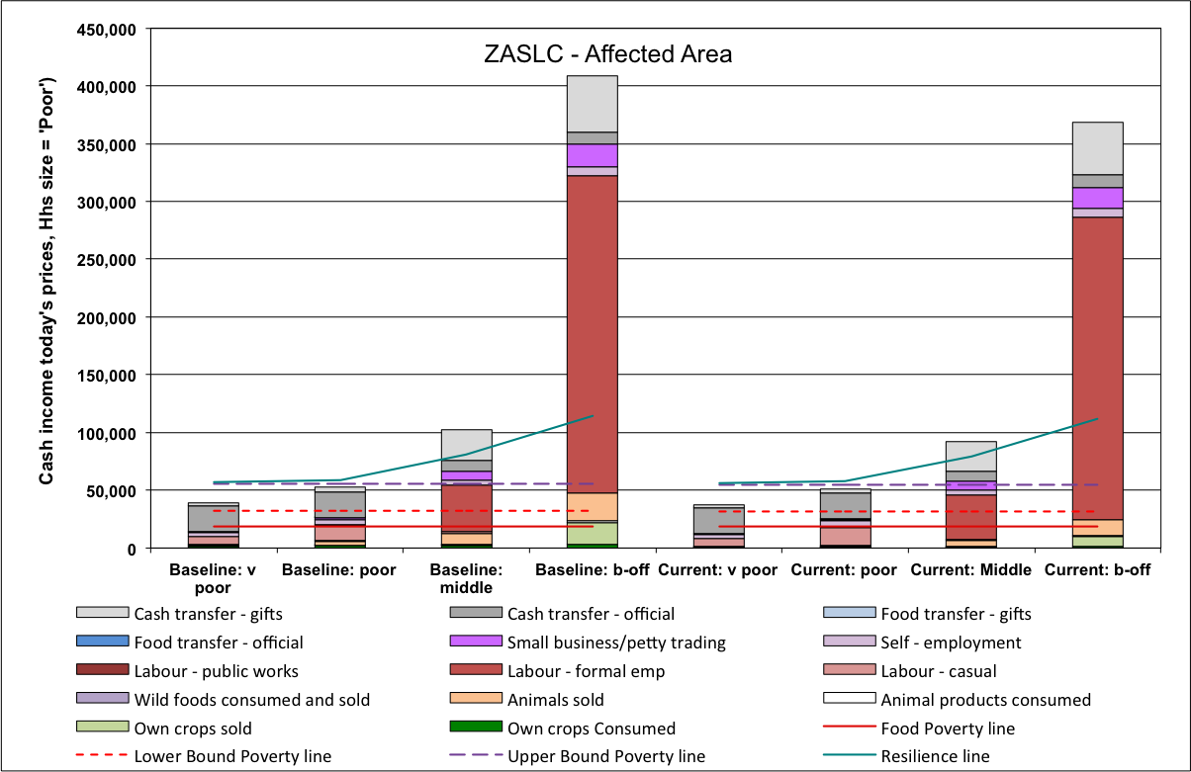9: Total income for all wealth groups in the drought-affected areas of Southern Limpopo Open Access Cattle and Crops livelihood zone

**Northern Open Access Cattle and Dry Land Crops (ZANOC)**

**Table 7** provides a summary of the total incomes for the 'poor' and 'very poor' wealth groups against this year's poverty lines (FPL, LBPL and UBPL). As can be seen in the table, neither wealth group is below either the FPL or the LBPL, whether drought-affected or not. However, the 'very poor' are below the UBPL in both the drought-affected and not affected areas, while the 'poor' are below the UBPL in the drought-affected areas only. It is important to note that both the 'very poor' and 'poor' also suffer a UBPL deficit in the baseline year and *under today's price regimes*, the 'very poor' are actually in a marginally better position, while the 'poor' in the drought areas have a deficit and this deficit is slightly worse than the baseline.

**Figure 10** is a chart showing the some details of all wealth groups' total income in the *affected part* of the livelihood zone. The chart is based on the cost of the FPL, and normalises all the income as other poverty lines against this; the apparent reduction in incomes actually results from the rise in the cost of the FPL—in purely nominal terms, households' incomes actually rise for the current year (April 2015 to March 2016) when compared with the baseline (April 2013 to March 2014).

Table 7 - comparison of 'Poor' and 'Very poor' household incomes between baseline, unaffected and drought-affected areas in the Northern Open Access Cattle and Dry Land Crops livelihood zone this year

|  |  |  |  |  |  |  |
| --- | --- | --- | --- | --- | --- | --- |
| Measure | Cash equivalent in today's Rands | | | | | |
| 'Very Poor' wealth group | | | 'Poor' wealth group | | |
| Baseline | Unaffected areas | Affected areas | Baseline | Unaffected areas | Affected areas |
| TOTAL Income | 39,954 | 41,142 | 40,808 | 51,864 | 52,036 | 50,603 |
| FOOD POVERTY | 21,864 | 21,864 | 21,864 | 21,864 | 21,864 | 21,864 |
| **Food Poverty Deficit** | **0** | **0** | **0** | **0** | **0** | **0** |
| LOWER BOUND POVERTY | 35,135 | 34,833 | 34,833 | 35,135 | 34,833 | 34,833 |
| **Lower Bound Deficit** | **0** | **0** | **0** | **0** | **0** | **0** |
| UPPER BOUND POVERTY | 58,769 | 57,930 | 57,930 | 58,769 | 57,930 | 57,930 |
| **Upper Bound Deficit** | **18,815** | **16,788** | **17,122** | **6,905** | **0** | **7,327** |

##### **High Food Price Scenario**

Commercial farmers in South Africa are also facing a production crisis that could result in local supply shortfalls, while the recent slide in the value of the Rand could possibly raise the cost of imports significantly. The 'very poor' and ‘poor’ households in this zone are very reliant on food purchases, obtaining, respectively, approximately 93% and 70% of their total annual food energy intake from this source. This makes them vulnerable to price increases. For any wealth group to experience a Food Poverty Deficit (and therefore face starvation) in this livelihood zone, the price of foodstuffs will need to rise by 114% when compared with 2013-2014 levels (the new price would be 2.14 times the baseline). This means that maize, which retailed for R 5.38 a kilogram in 2013-2014, would have to cost R 11.50 currently. For households from any wealth group to fall below the Lower Bound Poverty Line (a measure of dire poverty), the prices of food stuffs will need to rise by 46% when compared with 2013-2014 levels (the new price would be 1.46 times the baseline). This means that maize would cost R 7.85 instead of R 5.38 in the baseline.

Figure 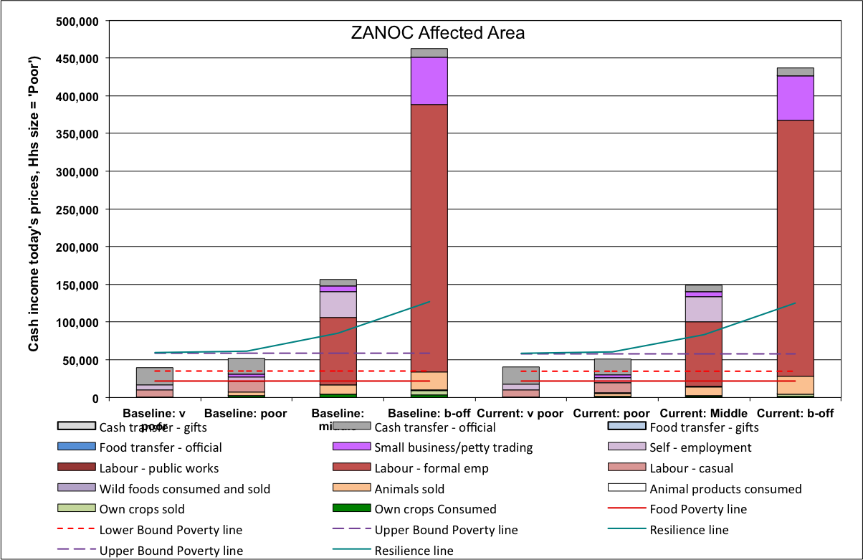10: Total income for all wealth groups in the drought-affected areas of Northern Open Access Cattle and Dry Land Crops livelihood zone

**Lowveld Open Access Irrigated Cropping (ZALOI)**

‘Very poor’ and ‘poor’ households in this zone purchase 57% and 65%, respectively, of their total food energy intake. This is somewhat less than other livelihood zones and it demonstrates that they depend a little more on their own agriculture, making them slightly more vulnerable to crop failure from drought than other livelihoods.

**Table 8** provides a summary of the total incomes for the 'poor' and 'very poor' wealth groups against this year's poverty lines (FPL, LBPL and UBPL). As can be seen in the table, neither wealth group is below either the FPL, whether drought-affected or not. However, the 'very poor' are below both the LBPL and the UBPL in both drought-affected and non-affected areas, while the 'poor' are not below either. It is important to note that the 'very poor' also suffer a LBPL deficit in the baseline year—this has worsened by R 760 in the non-affected areas and R 2,046 in the affected areas, meaning that their increased poverty is a function of both the present price regime as well as the drought.

Table 8 - comparison of 'Poor' and 'Very poor' household incomes between baseline, unaffected and drought-affected areas in the Lowveld Open Irrigated Cropping livelihood zone this year

|  |  |  |  |  |  |  |
| --- | --- | --- | --- | --- | --- | --- |
| Measure | Cash equivalent in today's Rands | | | | | |
| 'Very Poor' wealth group | | | 'Poor' wealth group | | |
| Baseline | Unaffected areas | Affected areas | Baseline | Unaffected areas | Affected areas |
| TOTAL Income | 38,184 | 37,030 | 35,744 | 80,912 | 76,632 | 73,939 |
| FOOD POVERTY | 29,947 | 29,947 | 29,947 | 29,947 | 29,947 | 29,947 |
| **Food Poverty Deficit** | **0** | **0** | **0** | **0** | **0** | **0** |
| LOWER BOUND POVERTY | 47,026 | 46,632 | 46,632 | 47,026 | 46,632 | 46,632 |
| **Lower Bound Deficit** | **8,842** | **9,602** | **10,888** | **0** | **0** | **0** |
| UPPER BOUND POVERTY | 74,610 | 73,578 | 73,578 | 74,610 | 73,578 | 73,578 |
| **Upper Bound Deficit** | **36,426** | **36,548** | **37,834** | **0** | **0** | **0** |

**Figure 11** is a chart showing the some details of all wealth groups' total income in the *affected part* of the livelihood zone. The chart is based on the cost of the FPL, and normalises all the income as other poverty lines against this; the apparent reduction in incomes actually results from the rise in the cost of the FPL—in purely nominal terms, households' incomes actually rise for the current year (April 2015 to March 2016) when compared with the baseline (April 2013 to March 2014).

Figure 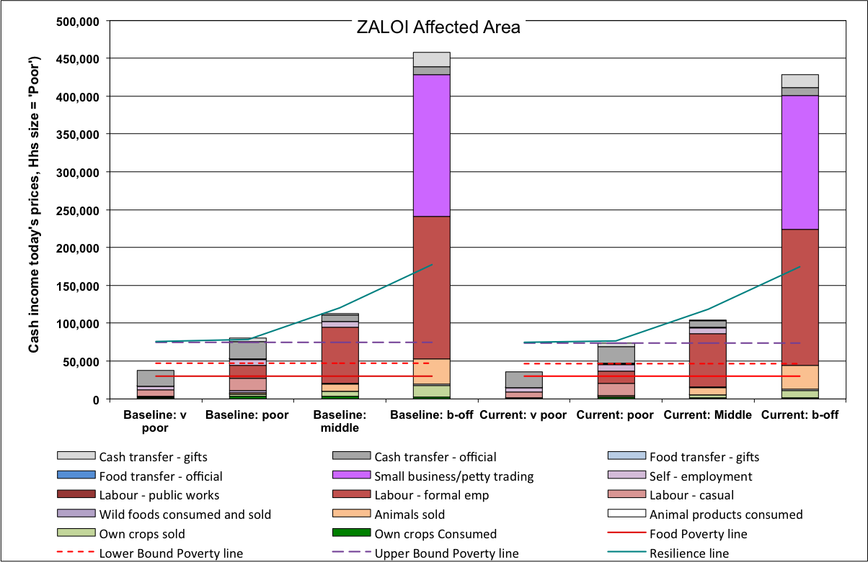11: Total income for all wealth groups in the drought-affected areas of Lowveld Open Access Irrigated Cropping livelihood zone

##### **High Food Price Scenario**

Commercial farmers in South Africa are also facing a production crisis that could result in local supply shortfalls, while the recent slide in the value of the Rand could possibly raise the cost of imports significantly. Households in this zone are vulnerable to price increases and for any wealth group to experience a Food Poverty Deficit (and therefore face starvation) in this livelihood zone, the price of foodstuffs will need to rise by 39% when compared with 2013-2014 levels (the new price would be 1.39 times the baseline). This means that maize, which retailed for R 4.00 a kilogram in 2013-2014, would have to cost R 5.56 currently.

**North Eastern Limpopo Open Access Crop Farming (ZALOF)**

‘Very poor’ and ‘poor’ households in this zone purchase 38% and 51%, respectively, of their total food energy intake. This is somewhat less than other livelihood zones and it demonstrates that they depend a little more on their own agriculture, making them more vulnerable to crop failure from drought than other livelihoods.

**Table 9** provides a summary of the total incomes for the 'poor' and 'very poor' wealth groups against this year's poverty lines (FPL, LBPL and UBPL). As can be seen in the table, neither wealth group is below either the FPL, whether drought-affected or not. However, the 'very poor' are below both the LBPL and the UBPL in both drought-affected and non-affected areas, while the 'poor' are not below either. It is important to note that the 'very poor' also suffer a LBPL deficit in the baseline year—this has worsened by R 184 in the non-affected areas and R 856 in the affected areas, meaning that their increased poverty is a function of both the present price regime as well as the drought.

**Figure 12** is a chart showing the some details of all wealth groups' total income in the *affected part* of the livelihood zone. The chart is based on the cost of the FPL, and normalises all the income as other poverty lines against this; the apparent reduction in incomes actually results from the rise in the cost of the FPL—in purely nominal terms, households' incomes actually rise for the current year (April 2015 to March 2016) when compared with the baseline (April 2013 to March 2014).

Table 9 - comparison of 'Poor' and 'Very poor' household incomes between baseline, unaffected and drought-affected areas in the Lowveld Open Irrigated Cropping livelihood zone this year

|  |  |  |  |  |  |  |
| --- | --- | --- | --- | --- | --- | --- |
| Measure | Cash equivalent in today's Rands | | | | | |
| 'Very Poor' wealth group | | | 'Poor' wealth group | | |
| Baseline | Unaffected areas | Affected areas | Baseline | Unaffected areas | Affected areas |
| TOTAL Income | 30,627 | 30,141 | 29,469 | 65,554 | 63,541 | 61,814 |
| FOOD POVERTY | 21,926 | 21,926 | 21,926 | 21,926 | 21,926 | 21,926 |
| **Food Poverty Deficit** | **0** | **0** | **0** | **0** | **0** | **0** |
| LOWER BOUND POVERTY | 35,197 | 34,895 | 34,895 | 35,197 | 34,895 | 34,895 |
| **Lower Bound Deficit** | **4,570** | **4,754** | **5,426** | **0** | **0** | **0** |
| UPPER BOUND POVERTY | 58,832 | 57,992 | 57,992 | 58,832 | 57,992 | 57,992 |
| **Upper Bound Deficit** | **28,205** | **27,851** | **28,523** | **0** | **0** | **0** |

Figure 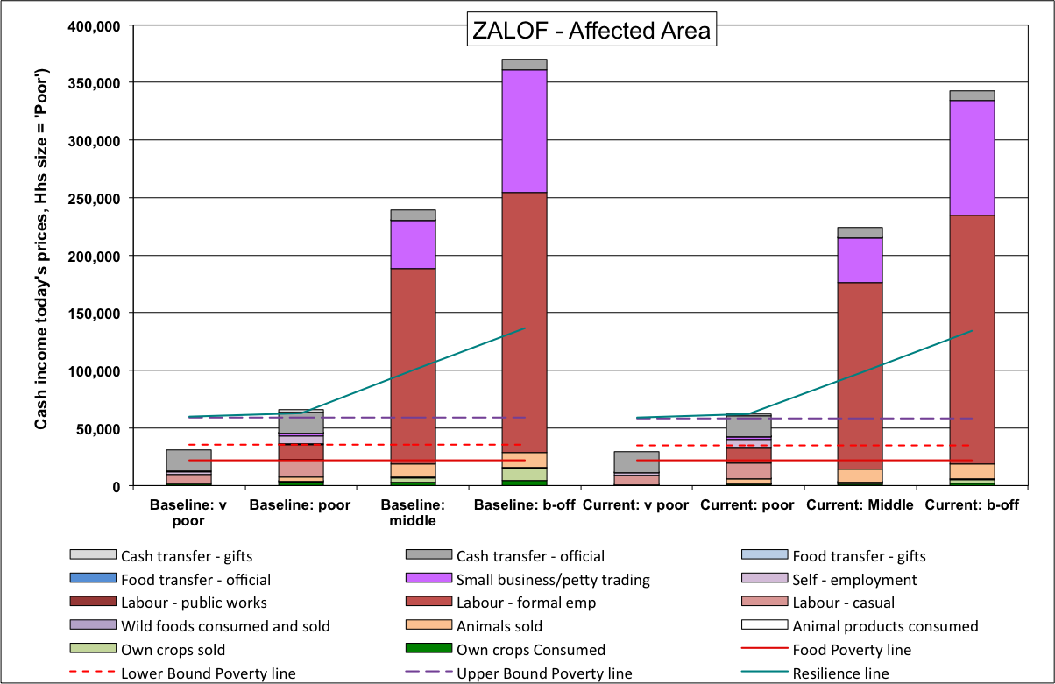12: Total income for all wealth groups in the drought-affected areas of the North Eastern Limpopo Open Access Crop Farming livelihood zone

##### **High Food Price Scenario**

Commercial farmers in South Africa are also facing a production crisis that could result in local supply shortfalls, while the recent slide in the value of the Rand could possibly raise the cost of imports significantly. Households in this zone are vulnerable to price increases and for any wealth group to experience a Food Poverty Deficit (and therefore face starvation) in this livelihood zone, the price of foodstuffs will need to rise by 61% when compared with 2013-2014 levels (the new price would be 1.61 times the baseline). This means that maize, which retailed for R 5.00 a kilogram in 2013-2014, would have to cost R 8.05 currently.

### Summary of Deficits in Livelihood Zones and Administrative Areas

The household deficits in each analysis are combined with population breakdowns for the livelihood zones in each administrative area. The tables overleaf are arranged as a cross-tabulated pivot table: Livelihood zones are in columns and districts or municipalities are in rows. Numbers are only reported if the livelihood zone is experiencing a deficit for at least one wealth group.

Populations below the Lower Bound Poverty Threshold, with the Total Deficits (total of amount below the LBPL)



Populations below the Upper Bound Poverty Threshold, with the Total Deficits (total of amount below the UBPL)

### Conclusion

In the current year, April 2014 to March 2016, households face problems with the current drought, including reduced food production, reduced opportunities for income, increases in prices of food and increases in prices of other essential household items. This impacts on the poorest households the most.

The ‘very poor’ households in all zones rely mostly on purchases (an average of 85% of their total annual food energy intake) and this makes them vulnerable to food price increases. The combination of high food and other commodity prices, constrained work opportunities (especially through reduced availability of both agricultural labour and domestic labour opportunities), augmented somewhat by poor crop production in April 2015, reduces household capacity to access quality food and a decent standard of living, defined by the Upper Bound Poverty Line. In the North Eastern Open Access Crop Farming and the Lowveld Open Access Irrigated Farming livelihood zones, 'very poor' households are living below the Lower Bound Poverty Line. Although the same outcomes exist in the baseline as well, the *margins of deficit have increased this year*.

Approximately 1,796,300 people are below the Upper Bound Poverty Line and their accumulated poverty gap is R 4.263 billion. Approximately 129,200 people are below the Lower Bound Poverty Line and their accumulated poverty gap is R 125.6 million.

### Recommendations

1. Government should consider an assistance package for the ‘very poor’ households which are likely to miss some of their livelihood entitlements in the coming three months. This could be in the form of scaling up social relief grants to increase household incomes;
2. The Extended Public Works Programme (EPWP) should be targeted to the very poor and poor households so as to increase the available employment slots, hence improving the frequency a household can benefit from the programme in a year;
3. The current SAVAC projections are based on current conditions such as current price of maize meal. An efficient monitoring system especially for the price of maize meal is required to be able to analyse the likely impact of further price increases on household access to food;
4. There is a high potential to increase household incomes through irrigation of vegetable production which is plentiful in the zone especially during the peak season. There is a need for further investigation of this potential medium- to longer-term economic intervention in the area;
5. There is a need to distribute government agricultural inputs in time to ensure timely operation of agricultural activities;
6. Improve access to community micro-financing for job creating opportunities

### Table of Areas Visited

|  |  |  |  |
| --- | --- | --- | --- |
| **District** | **Municipality** |  | **Selected Areas for the HEA** |
| **Southern Limpopo Open Access Cattle and Crops (ZASLC) Livelihood Zone** | | | |
| Capricorn | Lepele-Nkumpi | Atleast two | GaMakgoba A |
| Kwaripe |
| GaThaba |
| Greater Sekekhukhune | Elias Motsoaledi | Atleast one | Hlogotlou |
| Dikgalaopeng |
|  |
| Ephraim Mogale | Atleast two | Manotolwaneng |
| Tsimanyame |
| Ngwalemong |
| Makhuduthamaga | Atleast two | Manganeng |
| Masehlaneng |
| Matlakatle |
|  |
| Greater Tubatse | Atleast two | Ga-Manyaka |
| Kgautswana |
| Ga-Malekana |
| Fetakgomo | All | Mohlaletsi |
| Mopani | Maruleng | All | Finale |
| Greater Tzaneen | Atleast two | Hoveni |
| Mulati |
| Khujwana |
| Greater Letaba | All | Jamela |
| **Lowveld Open Access Irrigated Cropping (ZALOI) Livelihood Zone** | | | |
| Mopani | Greater Giyani | Atleast four | KaDzingidzingi |
| Bode |
| KaHomu |
| KaHhlaneki |
| KaNkomo |
| Vhembe | Thulamela | Atleast three | Matangari |
| Maraxwe |
| Makonde |
| Mbahela |
| Tshiombo |
| Mutale | All | Dzimauli |
| **North Eastern Limpopo Open Access Farming (ZALOF) Livelihood Zone** | | | |
| Vhembe | Thulamela | Atleast three | Malavuwe |
| Tshaulu |
| Mudzidzidzi |
| Mangondi A |
| Lambani |
| Milaboni |
| Mutale | All | Tshixwadza |
| Makhado | All  (Waterberg team) | Murunwa |
| Valdezia |
| Vuvha A |
| **Northern Open Access Cattle and Dry Land Crops (ZANOC) Livelihood Zone** | | | |
| Waterberg | Mogalakwena | All | GaMonare |
| Ga-Mushi |
|  |
| Lephalale | All | Melkbosch |
|  |
| Vhembe | Makhado | All  (Waterbeg team) | Maangani |
| Zamekomste |
|  |
| Thulamela |  | Themba Luvhilo |
| Capricorn | Polokwane | All | Ramakgaphola |
|  |
| Aganang | Atleast two | Mohlajeng |
| Monotwane |
| Glen Roy |
| Blouberg | All | Mmankgodi |
| My Darling |
| Molemole | All | Ga-Sako |

1. Wealth is defined in terms of asset holdings and incomes